Lab02 create a windows ec2 and login with rdp

Click on services and select EC2 instance ,click on launch instance

Choose AMI as Windows server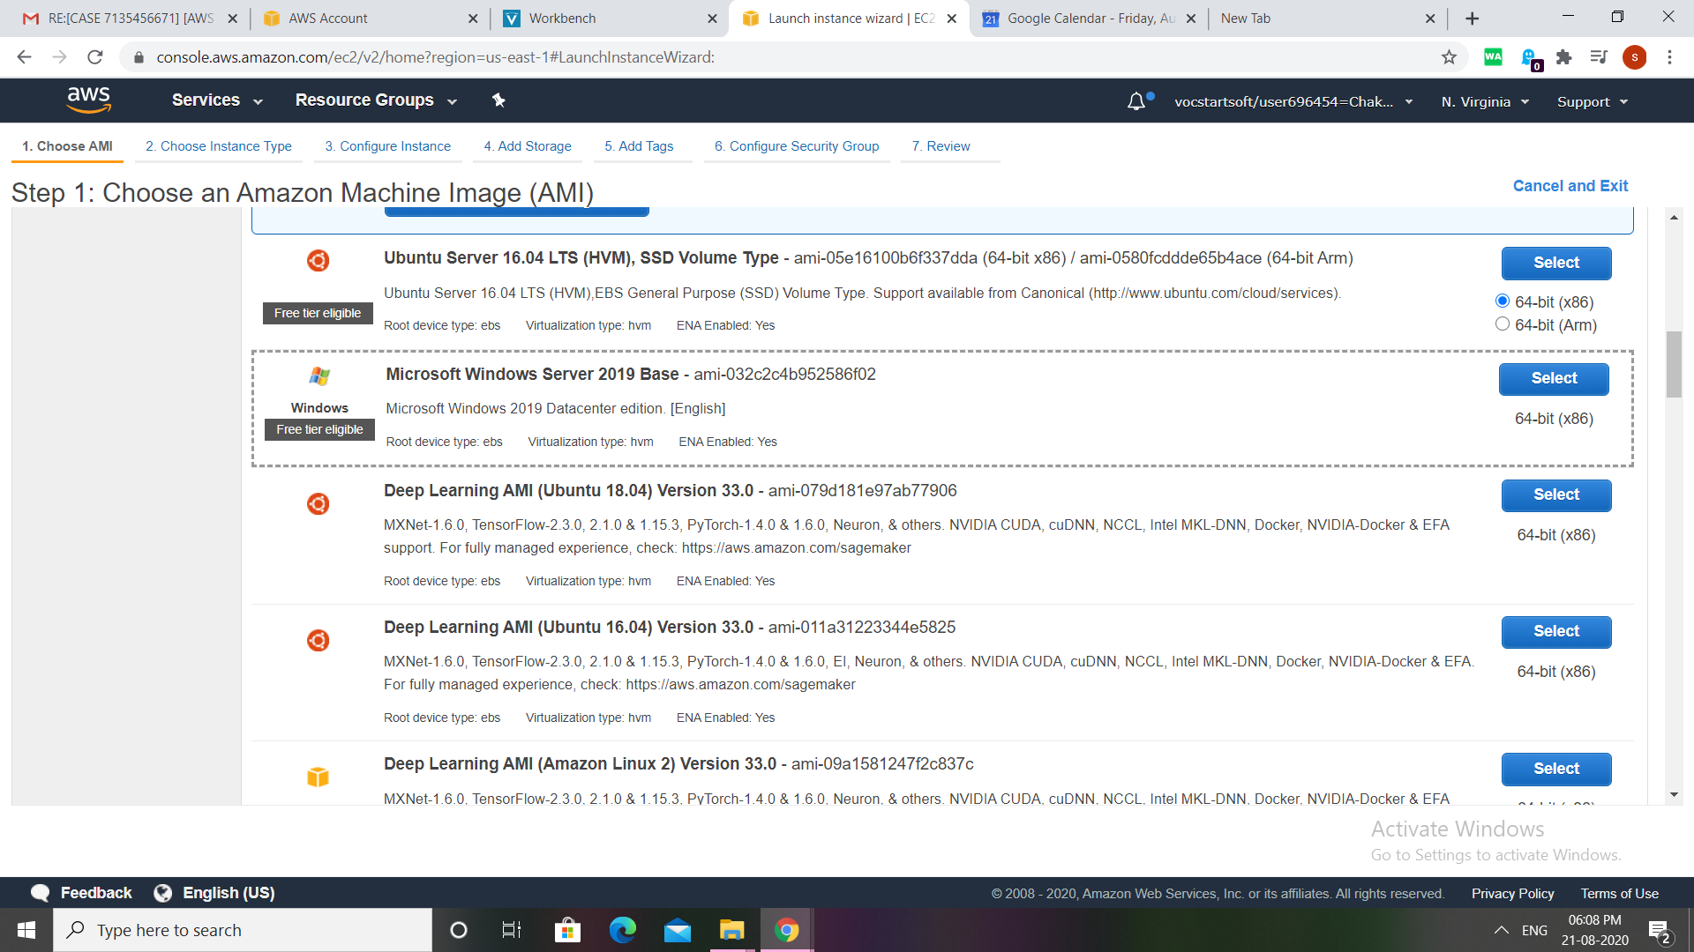Choose an instance type as free tier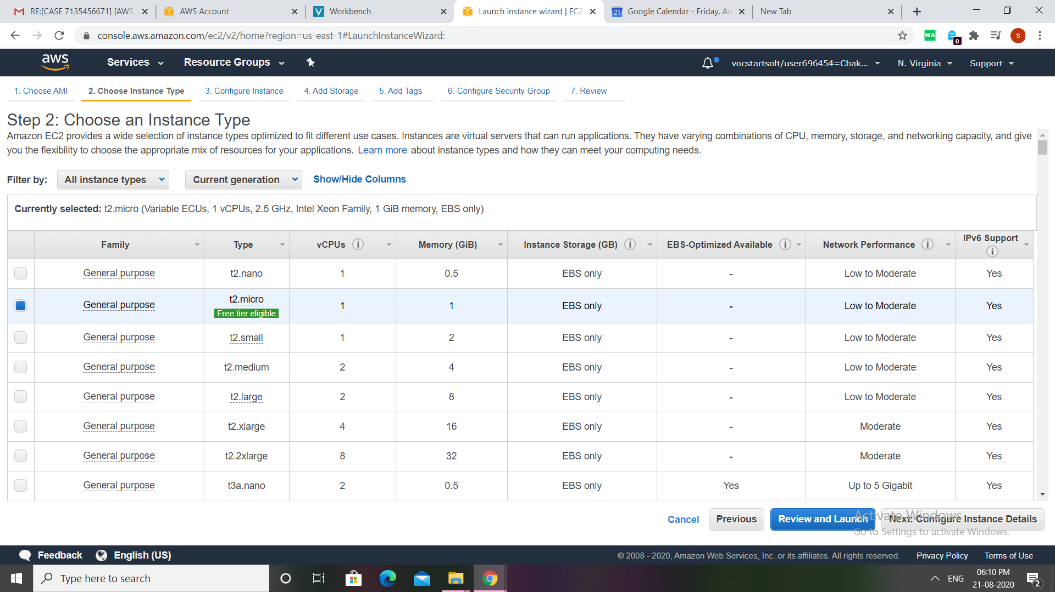

Configure instance details put it as default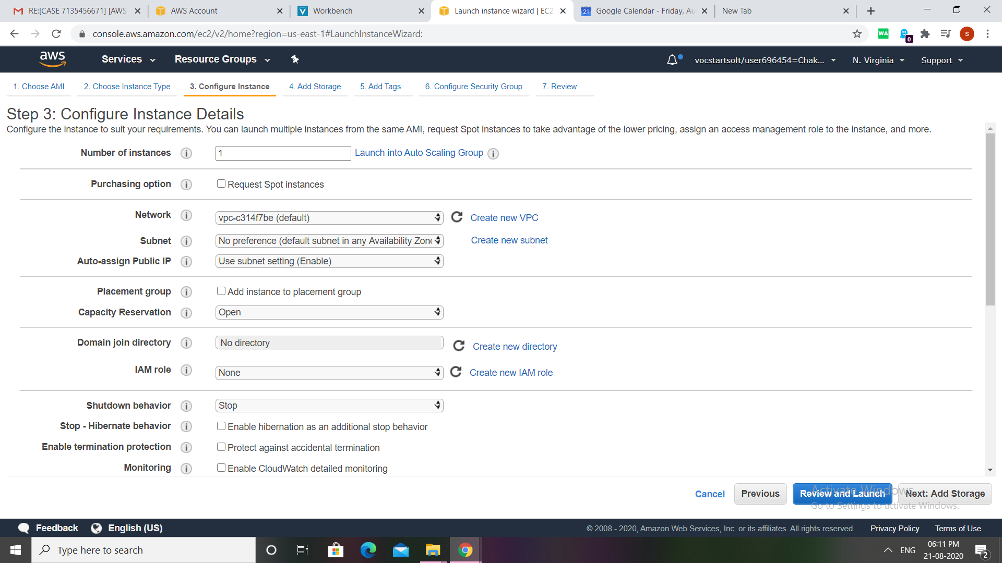addstorage keep it as defalut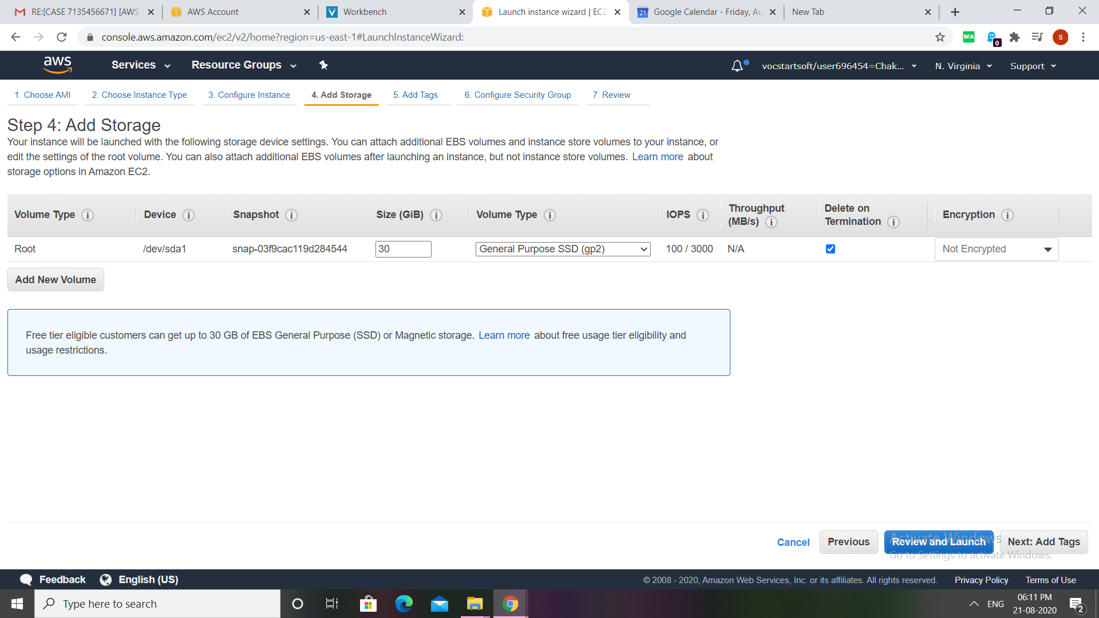

Add the tags :if we want we can add the tags these are basically to identify 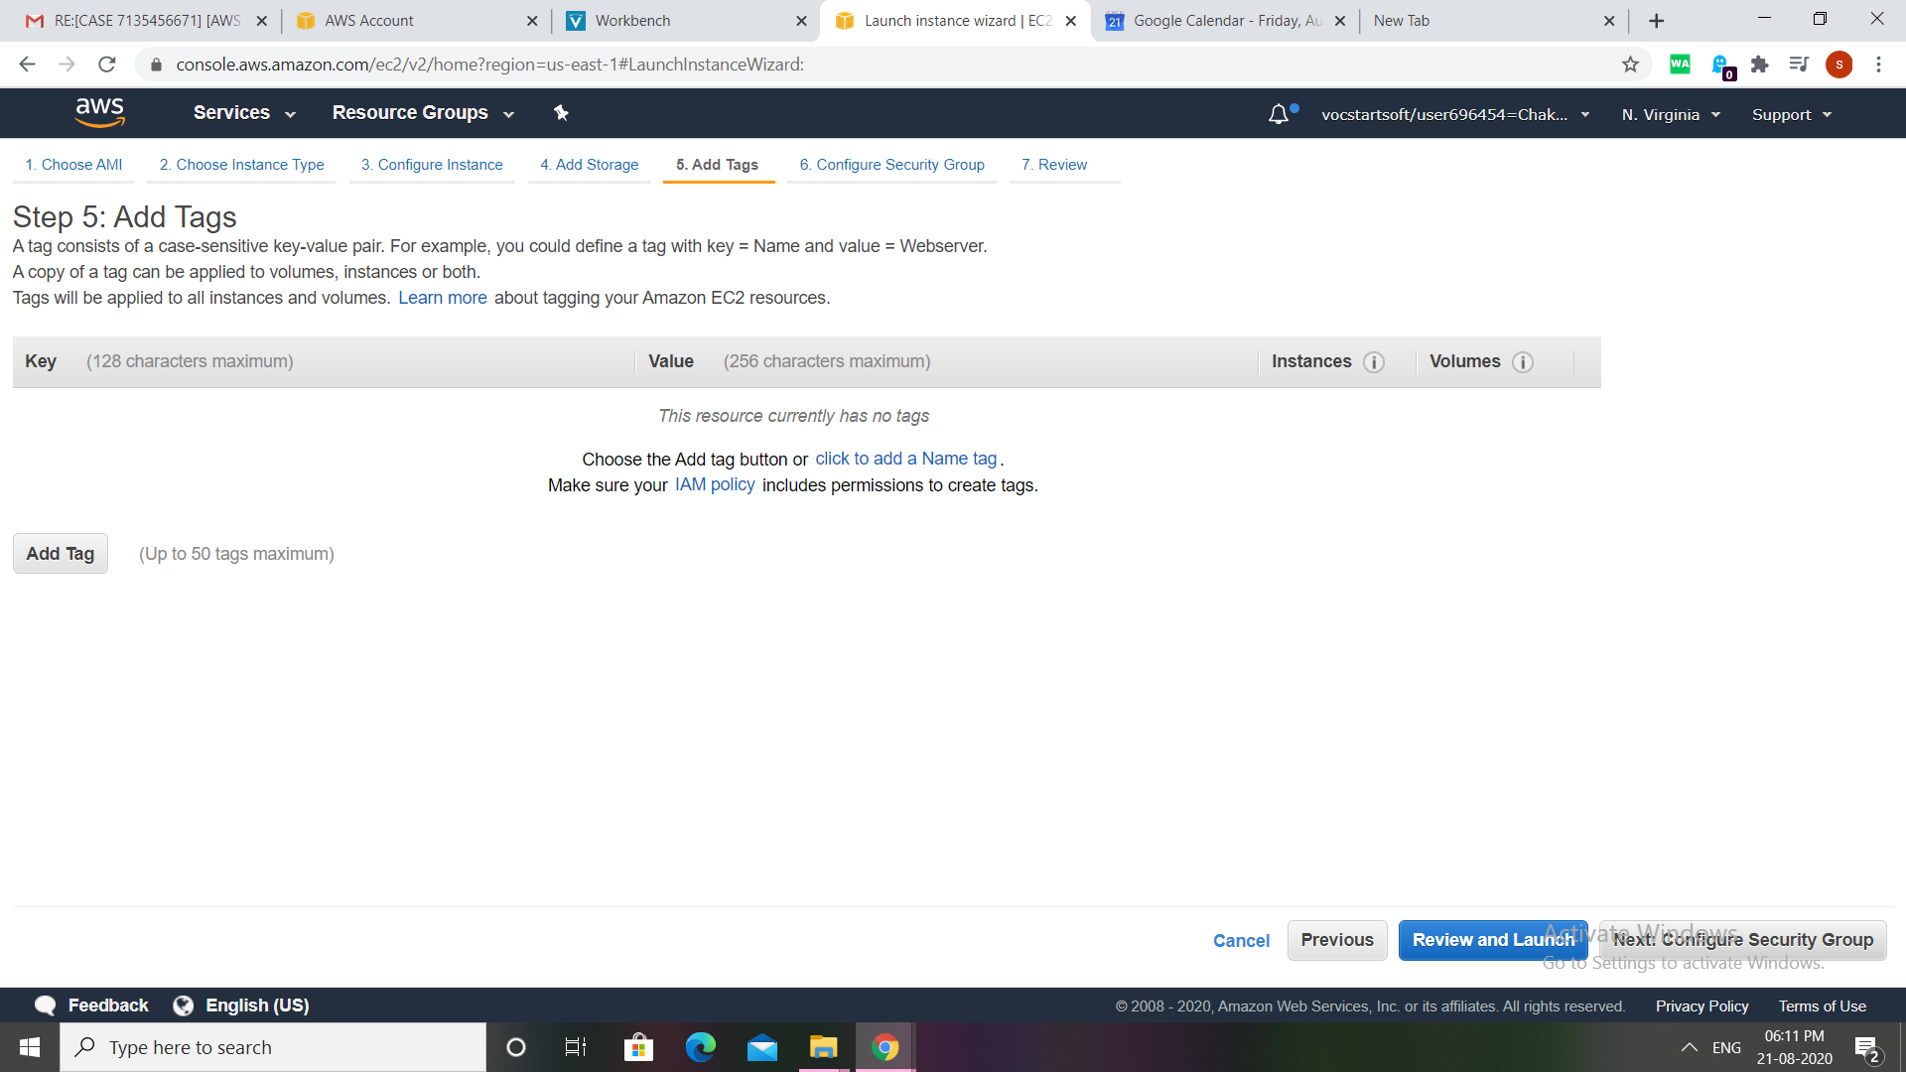

Select the one which we created previously .

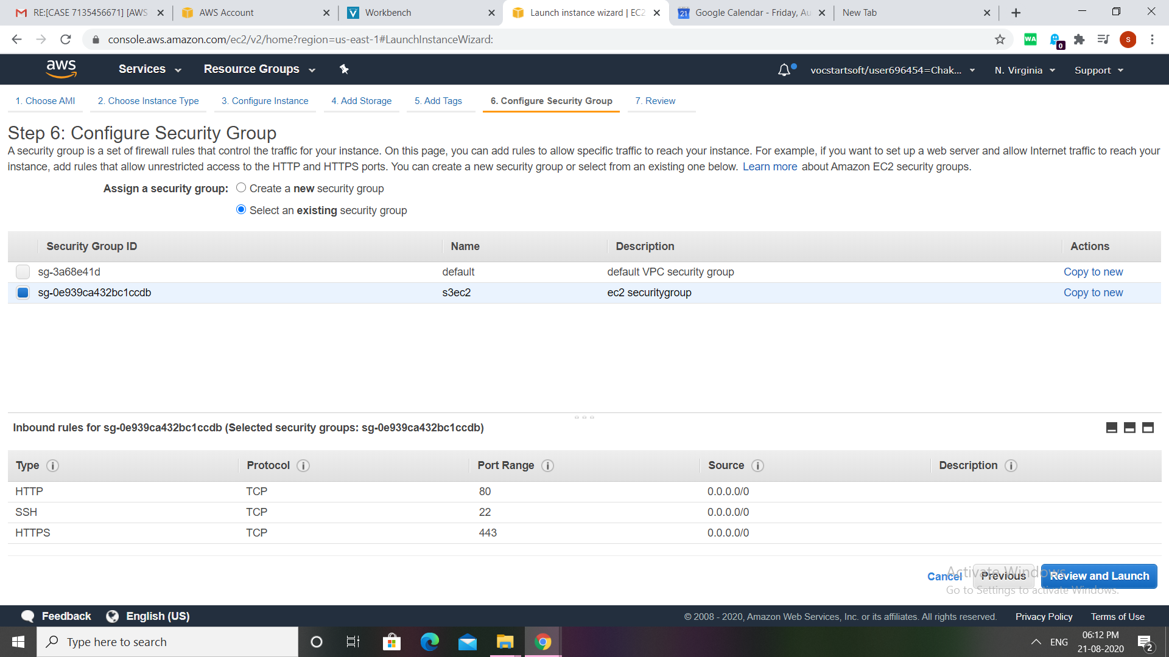

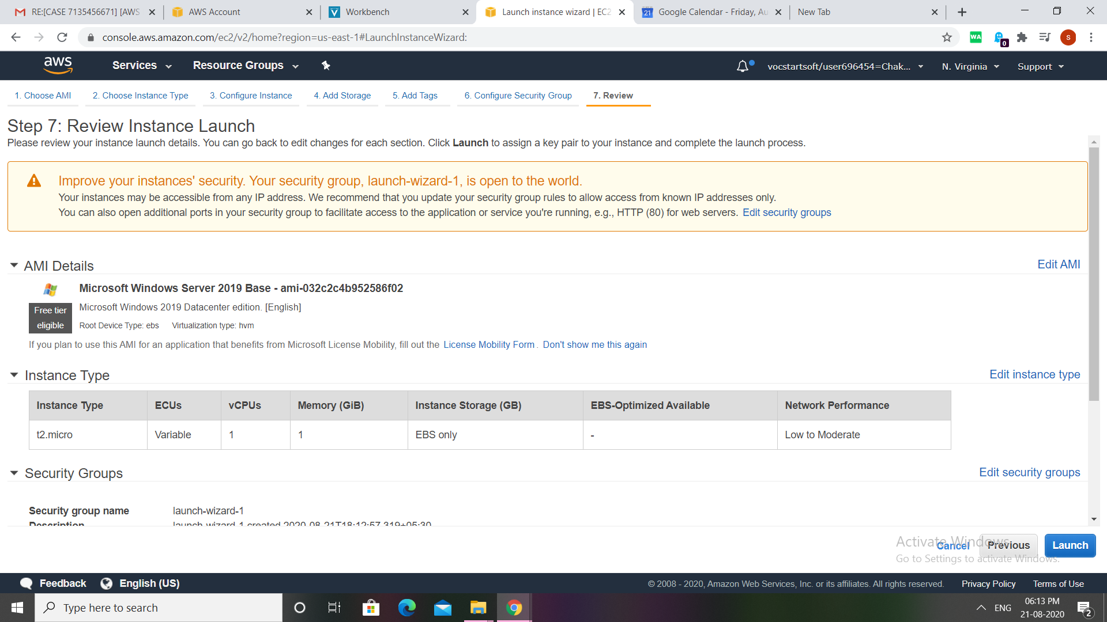

View 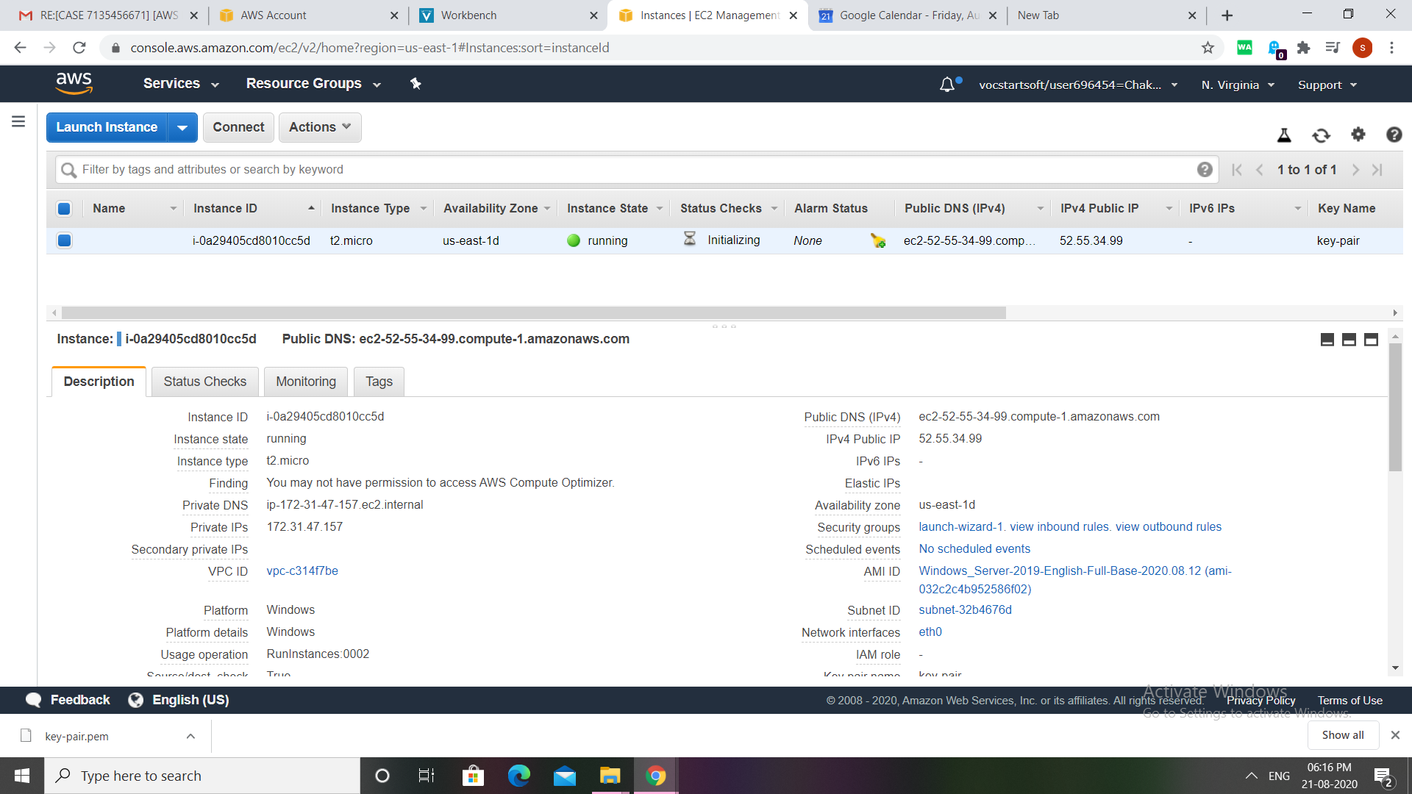

Now ,click on conncet 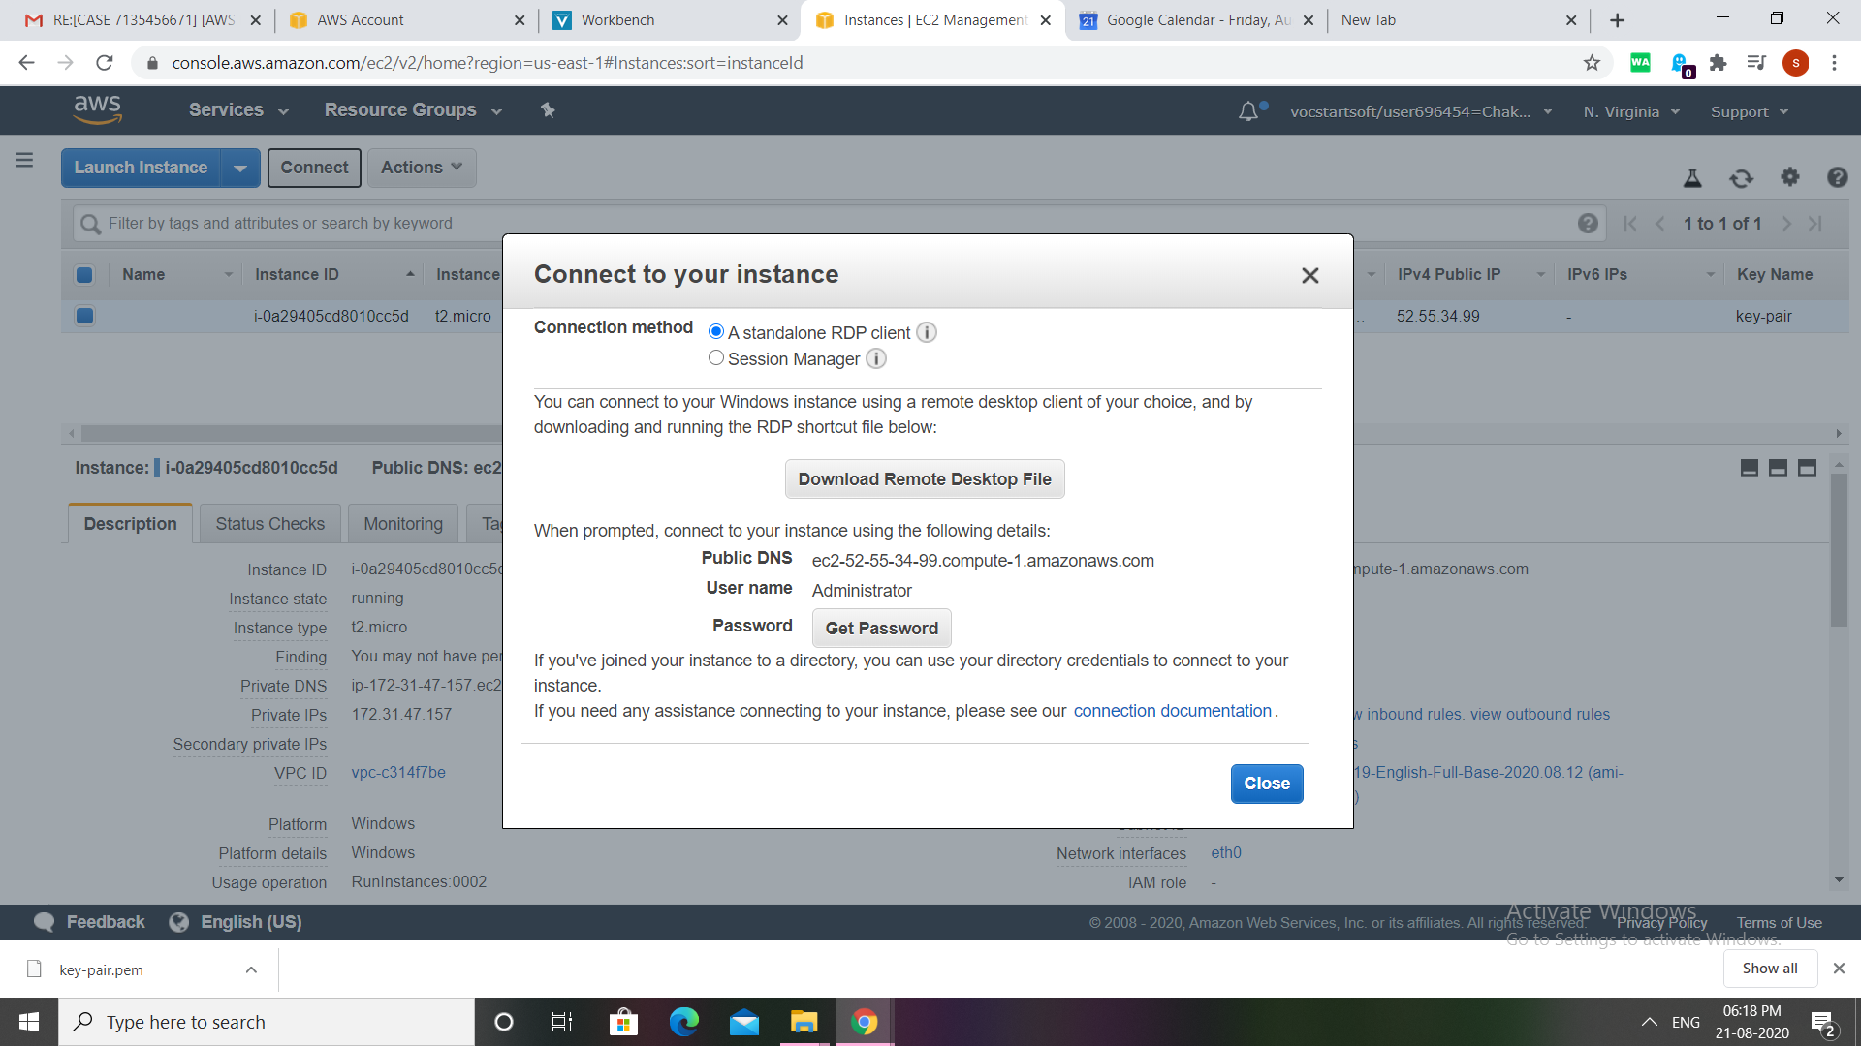

Click on get password,now choose the files from the keypair,next decrypt password.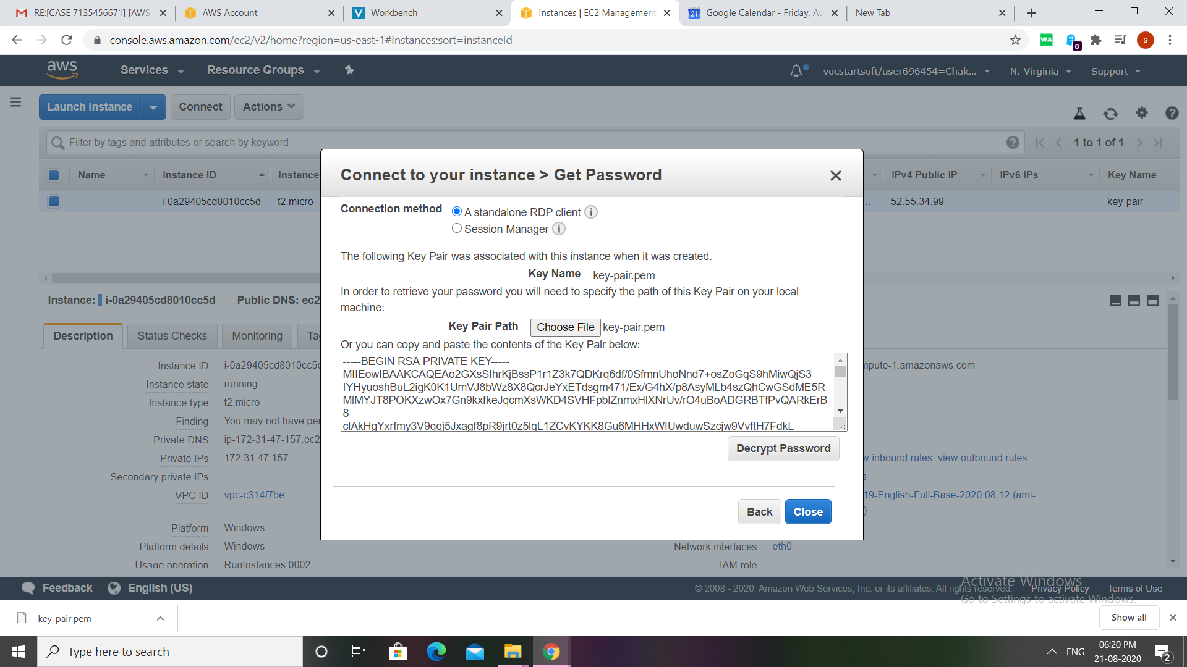

Now just copy the password ,now click on download remote desktop file 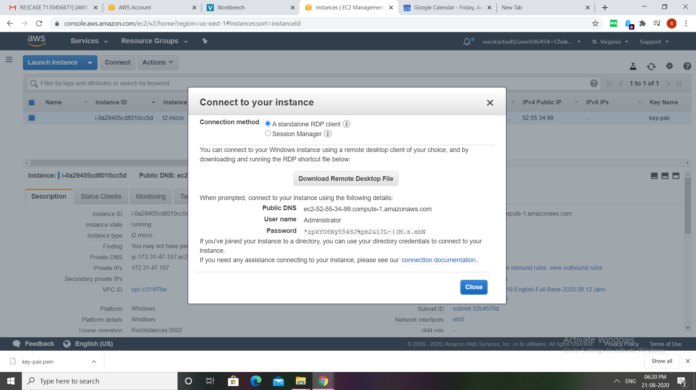

Now ,paste the passwordhere, then we will connect to the windows 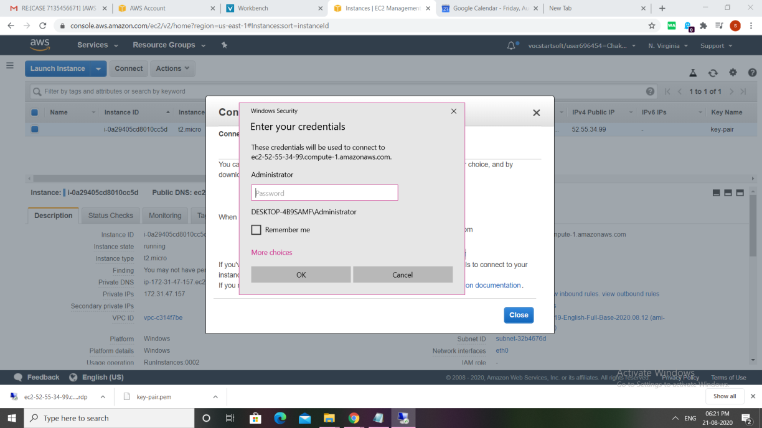

When we enter the passord ,this window will open ,final output window run on cloud.

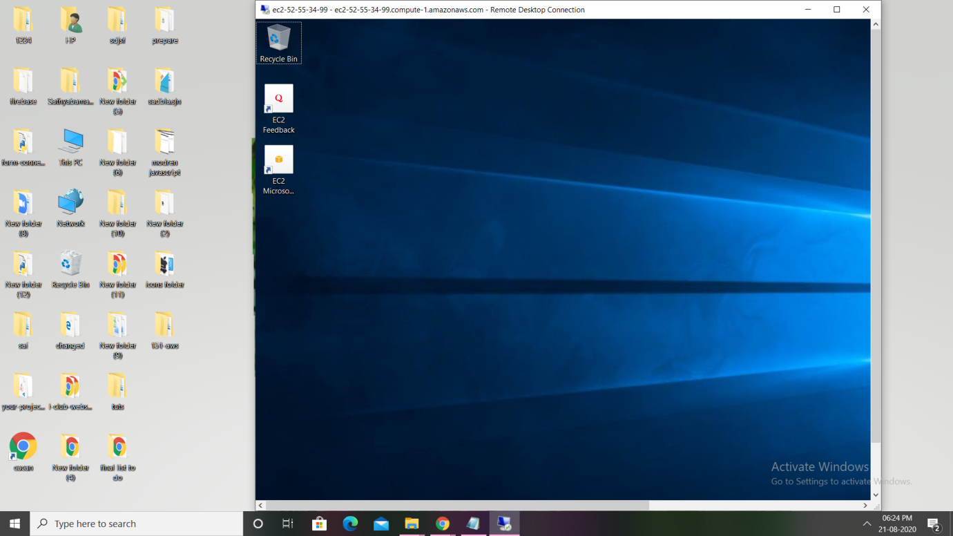

FINAL OUTPUT:

